
God’s Scope throughout the Bible II Chronicles 35

LightHouse Ranch
Bible Study
I. The Days of Noah
II. Abrahamic Covenant Central to all Prophecy
III. Moses and Isaiah Prophesied Two Land Removals
IV. The Apostacy of Judah
V. Second Return After the Scattering
VI. Christ Sets Up His Classroom
VII. Daniel Prophesies Both Advents and Returns
VIII. Don’t Be Ignorant of the Mystery
IX. The Kingdom After Israel is Returned
X. All Was Prophesied in the Feasts
XI. The Second Advent & Millennium
XII. The Eternal Kingdom
Where does the Apostasy of Judah fit into God’s Scope?
Isaiah 9:6 For unto us a child is born, unto us a son is given: and the government shall be upon his shoulder: and his name shall be called Wonderful, Counseller, The mighty God, The everlasting Father, The Prince of Peace.
Isaiah 9:7 Of the increase of his government and peace there shall be no end, upon the throne of David, and upon his kingdom, to order it, and to establish it with judgment and with justice from henceforth even for ever. The zeal of the LORD of hosts will perform this.

Prophesy throughout the Bible – “All points to the Day of the LORD”
From the Flood to Eternity Revealed by Straight Prophesy, Types, and Mysteries
I. The Days of Noah – Christ likened (type) Noah’s day to Christ’s 2nd Advent
Christ taught about the Flood and its type
Matthew 24:29 Immediately after the tribulation of those days shall the sun be darkened, and the moon shall not give her light, and the stars shall fall from heaven, and the powers of the heavens shall be shaken:
Matthew 24:30 And then shall appear the sign of the Son of man in heaven: and then shall all the tribes of the earth mourn, and they shall see the Son of man coming in the clouds of heaven with power and great glory.
Matthew 24:31 And he shall send his angels with a great sound of a trumpet, and they shall gather together his elect from the four winds, from one end of heaven to the other.
Matthew 24:32 Now learn a parable of the fig tree; When his branch is yet tender, and putteth forth leaves, ye know that summer is nigh:
Matthew 24:33 So likewise ye, when ye shall see all these things, know that it is near, even at the doors.
Matthew 24:34 Verily I say unto you, This generation shall not pass, till all these things be fulfilled.
Matthew 24:35 Heaven and earth shall pass away, but my words shall not pass away.
Matthew 24:36 But of that day and hour knoweth no man, no, not the angels of heaven, but my Father only.
Matthew 24:37 But as the days of Noe were, so shall also the coming of the Son of man be.
Matthew 24:38 For as in the days that were before the flood they were eating and drinking, marrying and giving in marriage, until the day that Noe entered into the ark,
Matthew 24:39 And knew not until the flood came, and took them all away; so shall also the coming of the Son of man be.
Enoch was translated before the “tribulation” of the Flood – Genesis 5-8
Genesis 5:21 And Enoch lived sixty and five years, and begat Methuselah:
Genesis 5:22 And Enoch walked with God after he begat Methuselah three hundred years, and begat sons and daughters:
Genesis 5:23 And all the days of Enoch were three hundred sixty and five years:
Genesis 5:24 And Enoch walked with God: and he was not; for God took him.
Genesis 5:25 And Methuselah lived an hundred eighty and seven years, and begat Lamech:
Noah became the Heir of Righteousness
Hebrews 11:7 By faith Noah, being warned of God of things not seen as yet, moved with fear, prepared an ark to the saving of his house; by the which he condemned the world, and became heir of the righteousness which is by faith.
The Type is clear: (Flood is a type – Righteous are translated first (Matthew 24; Genesis 5-8)
Types of the Rapture Teach at what point the Rapture Occurs
Enoch is translated into heaven before the flood  (A Type of the Tribulation) | Genesis 5:23-24; Flood Chapter 6
Lot is rescued out of Sodom before the fire fell  (A Type of the Tribulation) | Genesis 19:15; Fire Fell 19:23-24
Joseph takes a Gentile Bride Before the famine  (A Type of the Tribulation) | Joseph’s Egyptian Bride, Asenath – Genesis 41:45;  Famine started Genesis 41:54. (But there was bread in Egypt.)
Moses takes a Gentile Bride Before the Plagues  (A Type of the Tribulation) | Moses took his Midianite bride, Zipporah - Exodus 2:21-22; Plagues of Egypt begin in Chapter 7.
Each Event Happened Before The “Type” of the Tribulation
II. Abrahamic Covenant is Prophecy Central- (Genesis 12; Deuteronomy 30; II Samuel 7; Jeremiah 31)
Hebrews 11:6 But without faith it is impossible to please him: for he that cometh to God must believe that he is, and that he is a rewarder of them that diligently seek him.
Hebrews 11:7 By faith Noah, being warned of God of things not seen as yet, moved with fear, prepared an ark to the saving of his house; by the which he condemned the world, and became heir of the righteousness which is by faith.
Hebrews 11:8 By faith Abraham, when he was called to go out into a place which he should after receive for an inheritance, obeyed; and he went out, not knowing whither he went.
Hebrews 11:9 By faith he sojourned in the land of promise, as in a strange country, dwelling in tabernacles with Isaac and Jacob, the heirs with him of the same promise:
Hebrews 11:10 For he looked for a city which hath foundations, whose builder and maker is God.
Covenant with Abraham | Covenant Extensions
Promise of a National Land – (Land)  Genesis 12:1-3; 13:14-18 | Palestinian Covenant – God will regather Israel from the scattering, circumcise their heart and give eternal restoration Deuteronomy 30:3-5; Ezekiel 36-37
Promise of Numerous Descendants – A Great Nation – (Seed) Genesis 12:3; 13:16;17:1-22 | Davidic Covenant – David’s Seed on the throne of Israel forever II Samuel 7:1-16; Jeremiah 33:19-26; 31:35-37; Exodus 3:15; Luke 1
Promise that God will bless the world through Abraham– (World-wide Blessing through Abraham) Genesis 12:3; 22:1-19 | New Covenant – To Israel & Judah, No psychology, Law written in the heart, all will know God Jeremiah 31:31-40; Hebrews 8; Amos 9:11-15
Christ and the Gentiles – Scripture with foresight preached the Gospel to Abraham
Galatians 3 Interprets the Abrahamic Covenant in the New Testament
Galatians 3:6 Even as Abraham believed God, and it was accounted to him for righteousness.
Galatians 3:7 Know ye therefore that they which are of faith, the same are the children of Abraham.
Galatians 3:8 And the scripture, foreseeing that God would justify the heathen through faith, preached before the gospel unto Abraham, saying, In thee shall all nations be blessed.
Galatians 3:9 So then they which be of faith are blessed with faithful Abraham.
Galatians 3:29 And if ye be Christ’s, then are ye Abraham’s seed, and heirs according to the promise.
III. Moses and Isaiah Prophesied Two Removals from the Land
A. The Mosaic Covenant Reviewed – Deuteronomy 28:1-14
B. Moses’ Prophesy of the Babylonian Captivity – Deuteronomy 28:15-62
C. Moses’ Prophecy of the Scattering – Deuteronomy 28:63-68
D. Moses’ Prophesy of the church – Deuteronomy 32
E. Isaiah’s Prophesy of the Babylonian Captivity – Isaiah 39; 44-45
IV. The Apostacy of Judah – II Chronicles 36
The People made Josiah’s son, Jehoahaz king for 3 months after Josiah’s death
2 Chronicles 36:1 Then the people of the land took Jehoahaz the son of Josiah, and made him king in his father's stead in Jerusalem.
2 Chronicles 36:2 Jehoahaz was twenty and three years old when he began to reign, and he reigned three months in Jerusalem.
2 Chronicles 36:3 And the king of Egypt put him down at Jerusalem, and condemned the land in an hundred talents of silver and a talent of gold.
2 Chronicles 36:4 And the king of Egypt made Eliakim his brother king over Judah and Jerusalem, and turned his name to Jehoiakim. And Necho took Jehoahaz his brother, and carried him to Egypt.
Pharoah Necho made Eliakim king for 11 years changing his name to Jehoikim
2 Chronicles 36:5 Jehoiakim was twenty and five years old when he began to reign, and he reigned eleven years in Jerusalem: and he did that which was evil in the sight of the LORD his God.
2 Chronicles 36:6 Against him came up Nebuchadnezzar king of Babylon, and bound him in fetters, to carry him to Babylon.
2 Chronicles 36:7 Nebuchadnezzar also carried of the vessels of the house of the LORD to Babylon, and put them in his temple at Babylon.
2 Chronicles 36:8 Now the rest of the acts of Jehoiakim, and his abominations which he did, and that which was found in him, behold, they are written in the book of the kings of Israel and Judah: and Jehoiachin his son reigned in his stead.
Jehoiachin reigns in his father’s stead for three months and 10 days
2 Chronicles 36:9 Jehoiachin was eight years old when he began to reign, and he reigned three months and ten days in Jerusalem: and he did that which was evil in the sight of the LORD.
2 Chronicles 36:10 And when the year was expired, king Nebuchadnezzar sent, and brought him to Babylon, with the goodly vessels of the house of the LORD, and made Zedekiah his brother king over Judah and Jerusalem.
Zedekiah (Mattaniah), Jehoichin’s father’s brother reigns for 11 years
2 Chronicles 36:11 Zedekiah was one and twenty years old when he began to reign, and reigned eleven years in Jerusalem.
2 Chronicles 36:12 And he did that which was evil in the sight of the LORD his God, and humbled not himself before Jeremiah the prophet speaking from the mouth of the LORD.
Zedekiah rebelled against Nebuchadnezzar & the LORD – People and Priests transgress
2 Chronicles 36:13 And he also rebelled against king Nebuchadnezzar, who had made him swear by God: but he stiffened his neck, and hardened his heart from turning unto the LORD God of Israel.
2 Chronicles 36:14 Moreover all the chief of the priests, and the people, transgressed very much after all the abominations of the heathen; and polluted the house of the LORD which he had hallowed in Jerusalem.
Judah mocks the messengers of the LORD till there was no remedy
2 Chronicles 36:15 And the LORD God of their fathers sent to them by his messengers, rising up betimes, and sending; because he had compassion on his people, and on his dwelling place:
2 Chronicles 36:16 But they mocked the messengers of God, and despised his words, and misused his prophets, until the wrath of the LORD arose against his people, till there was no remedy.
Nebuchadnezzar
2 Chronicles 36:17 Therefore he brought upon them the king of the Chaldees, who slew their young men with the sword in the house of their sanctuary, and had no compassion upon young man or maiden, old man, or him that stooped for age: he gave them all into his hand.
2 Chronicles 36:18 And all the vessels of the house of God, great and small, and the treasures of the house of the LORD, and the treasures of the king, and of his princes; all these he brought to Babylon.
2 Chronicles 36:19 And they burnt the house of God, and brake down the wall of Jerusalem, and burnt all the palaces thereof with fire, and destroyed all the goodly vessels thereof.
God’s Purpose of the Babylonian Captivity – Had not observed the Sabbath of Years – Leviticus 25
2 Chronicles 36:20 And them that had escaped from the sword carried he away to Babylon; where they were servants to him and his sons until the reign of the kingdom of Persia:
Nebuchadnezzar fulfills the prophesies of Jeremiah fulfilling Sabbaths not observed
2 Chronicles 36:21 To fulfil the word of the LORD by the mouth of Jeremiah, until the land had enjoyed her sabbaths: for as long as she lay desolate she kept sabbath, to fulfil threescore and ten years.
The First Return fulfilled
2 Chronicles 36:22 Now in the first year of Cyrus king of Persia, that the word of the LORD spoken by the mouth of Jeremiah might be accomplished, the LORD stirred up the spirit of Cyrus king of Persia, that he made a proclamation throughout all his kingdom, and put it also in writing, saying,
2 Chronicles 36:23 Thus saith Cyrus king of Persia, All the kingdoms of the earth hath the LORD God of heaven given me; and he hath charged me to build him an house in Jerusalem, which is in Judah. Who is there among you of all his people? The LORD his God be with him, and let him go up.
V. Second Return After the Scattering
The First Return Prophesied
A. Jeremiah 27
B. Isaiah 44-45
The Second Return Prophesied
A. Isaiah 11:10-16 – Involves the 2nd Advent and the Gentiles will
B. Deuteronomy 4:25-30 – The 1st Return a type of the 2nd Advent - To the Ensign Gentiles shall seek
C. Deuteronomy 30:1-14 – The Palestinian Covenant extension of the Abrahamic Covenant
VI. Christ Sets Up His Classroom to Answer His Disciples’ Questions
The Second Return at the end of the Great Tribulation
After the Triumphant Entry, Christ lays down deserved judgment on the Pharisees in Jerusalem saying that prophets have been sent to Jerusalem and they and their fathers have killed those prophets, they personally will “fill up the measure of your fathers”. Christ answers the disciples questions about the “Last Days”.
Matthew 23:36 Verily I say unto you, All these things shall come upon this generation.
Matthew 23:37 O Jerusalem, Jerusalem, thou that killest the prophets, and stonest them which are sent unto thee, how often would I have gathered thy children together, even as a hen gathereth her chickens under her wings, and ye would not!
Matthew 23:38 Behold, your house is left unto you desolate.
Matthew 23:39 For I say unto you, Ye shall not see me henceforth, till ye shall say, Blessed is he that cometh in the name of the Lord.
Matthew 24:1 And Jesus went out, and departed from the temple: and his disciples came to him for to shew him the buildings of the temple.
Matthew 24:2 And Jesus said unto them, See ye not all these things? verily I say unto you, There shall not be left here one stone upon another, that shall not be thrown down.
Matthew 24:3 And as he sat upon the mount of Olives, the disciples came unto him privately, saying, Tell us, when shall these things be? and what shall be the sign of thy coming, and of the end of the world?
Matthew 24:4 And Jesus answered and said unto them, Take heed that no man deceive you.
Matthew 24:5 For many shall come in my name, saying, I am Christ; and shall deceive many.
Matthew 24:6 And ye shall hear of wars and rumours of wars: see that ye be not troubled: for all these things must come to pass, but the end is not yet.
Matthew 24:7 For nation shall rise against nation, and kingdom against kingdom: and there shall be famines, and pestilences, and earthquakes, in divers places.
Matthew 24:8 All these are the beginning of sorrows.
Matthew 24:9 Then shall they deliver you up to be afflicted, and shall kill you: and ye shall be hated of all nations for my name's sake.
Matthew 24:10 And then shall many be offended, and shall betray one another, and shall hate one another.
Matthew 24:11 And many false prophets shall rise, and shall deceive many.
Matthew 24:12 And because iniquity shall abound, the love of many shall wax cold.
Matthew 24:13 But he that shall endure unto the end, the same shall be saved.
Matthew 24:14 And this gospel of the kingdom shall be preached in all the world for a witness unto all nations; and then shall the end come.
Matthew 24:15 When ye therefore shall see the abomination of desolation, spoken of by Daniel the prophet, stand in the holy place, (whoso readeth, let him understand:)
Matthew 24:16 Then let them which be in Judaea flee into the mountains:
Matthew 24:17 Let him which is on the housetop not come down to take any thing out of his house:
Matthew 24:18 Neither let him which is in the field return back to take his clothes.
Matthew 24:19 And woe unto them that are with child, and to them that give suck in those days!
Matthew 24:20 But pray ye that your flight be not in the winter, neither on the sabbath day:
Matthew 24:21 For then shall be great tribulation, such as was not since the beginning of the world to this time, no, nor ever shall be.
Matthew 24:22 And except those days should be shortened, there should no flesh be saved: but for the elect's sake those days shall be shortened.
Matthew 24:23 Then if any man shall say unto you, Lo, here is Christ, or there; believe it not.
Matthew 24:24 For there shall arise false Christs, and false prophets, and shall shew great signs and wonders; insomuch that, if it were possible, they shall deceive the very elect.
Matthew 24:25 Behold, I have told you before.
Matthew 24:26 Wherefore if they shall say unto you, Behold, he is in the desert; go not forth: behold, he is in the secret chambers; believe it not.
Matthew 24:27 For as the lightning cometh out of the east, and shineth even unto the west; so shall also the coming of the Son of man be.
Matthew 24:28 For wheresoever the carcase is, there will the eagles be gathered together.
Matthew 24:29 Immediately after the tribulation of those days shall the sun be darkened, and the moon shall not give her light, and the stars shall fall from heaven, and the powers of the heavens shall be shaken:
Matthew 24:30 And then shall appear the sign of the Son of man in heaven: and then shall all the tribes of the earth mourn, and they shall see the Son of man coming in the clouds of heaven with power and great glory.
Matthew 24:31 And he shall send his angels with a great sound of a trumpet, and they shall gather together his elect from the four winds, from one end of heaven to the other.
Matthew 24:32 Now learn a parable of the fig tree; When his branch is yet tender, and putteth forth leaves, ye know that summer is nigh:
Matthew 24:33 So likewise ye, when ye shall see all these things, know that it is near, even at the doors.
Matthew 24:34 Verily I say unto you, This generation shall not pass, till all these things be fulfilled.
Matthew 24:35 Heaven and earth shall pass away, but my words shall not pass away.
Matthew 24:36 But of that day and hour knoweth no man, no, not the angels of heaven, but my Father only.
Matthew 24:37 But as the days of Noe were, so shall also the coming of the Son of man be.
Matthew 24:38 For as in the days that were before the flood they were eating and drinking, marrying and giving in marriage, until the day that Noe entered into the ark,
Matthew 24:39 And knew not until the flood came, and took them all away; so shall also the coming of the Son of man be.
Matthew 24:40 Then shall two be in the field; the one shall be taken, and the other left.
Matthew 24:41 Two women shall be grinding at the mill; the one shall be taken, and the other left.
Matthew 24:42 Watch therefore: for ye know not what hour your Lord doth come.
Matthew 24:43 But know this, that if the goodman of the house had known in what watch the thief would come, he would have watched, and would not have suffered his house to be broken up.
Matthew 24:44 Therefore be ye also ready: for in such an hour as ye think not the Son of man cometh.
Matthew 24:45 Who then is a faithful and wise servant, whom his lord hath made ruler over his household, to give them meat in due season?
Matthew 24:46 Blessed is that servant, whom his lord when he cometh shall find so doing.
Matthew 24:47 Verily I say unto you, That he shall make him ruler over all his goods.
Matthew 24:48 But and if that evil servant shall say in his heart, My lord delayeth his coming;
Matthew 24:49 And shall begin to smite his fellowservants, and to eat and drink with the drunken;
Matthew 24:50 The lord of that servant shall come in a day when he looketh not for him, and in an hour that he is not aware of,
Matthew 24:51 And shall cut him asunder, and appoint him his portion with the hypocrites: there shall be weeping and gnashing of teeth.
VII. Daniel Prophesies Concerning both Advents and Returns
Daniel 9:25 Know therefore and understand, that from the going forth of the commandment to restore and to build Jerusalem unto the Messiah the Prince shall be seven weeks, and threescore and two weeks: the street shall be built again, and the wall, even in troublous times.
A. From the decree – 7 weeks (49 years) - The commandment to restore and to build Jerusalem
B. Unto the Messiah the Prince – 62 weeks – (434 years)
C. After the 62 weeks - 1 week (7 years)
Daniel 9:26 And after threescore and two weeks shall Messiah be cut off, but not for himself: and the people of the prince that shall come shall destroy the city and the sanctuary; and the end thereof shall be with a flood, and unto the end of the war desolations are determined.
Daniel’s Seventy Weeks - 1 week = 7 years; 70 weeks times 7 = 490 years total in 70 weeks (or 490 years) divided into 3 periods:
From Decree 7 weeks - 49 yrs., Unto Messiah the Prince 62 weeks - 434 yrs., After the 62-1 week, 7 yrs.
 |  |  | †
From Decree to rebuild Jerusalem | Street and wall rebuilt | Messiah the Prince  Entry | Messiah Cut off  Jerusalem Destroyed 70 AD  Church Rapture |  | Antichrist Covenant,  breaks it 3 ½ yrs in the midst  Abomination of Desolation | 2ndAdvent
7 weeks=  49 years |  | 62 weeks=  434 years | Church Age - Not Revealed To Daniel |  | 70th week=  7 years
70 weeks = 490 years - Red = Figures given to Daniel in chapter 9
Daniel 9:27 And he shall confirm the covenant with many for one week: and in the midst of the week he shall cause the sacrifice and the oblation to cease, and for the overspreading of abominations he shall make it desolate, even until the consummation, and that determined shall be poured upon the desolate.

Daniel 2 | Daniel 7 | Zachariah 1  Daniel 8 | Revelation 13 | Stone Cut without Hands
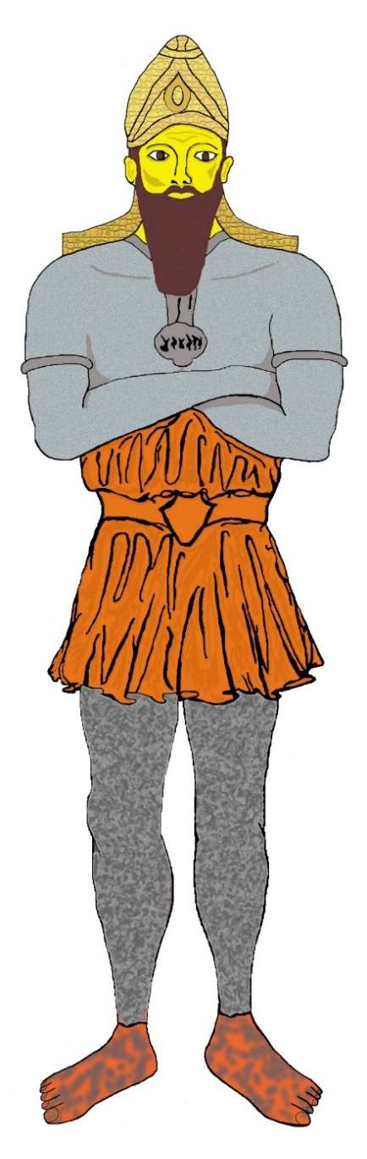 | 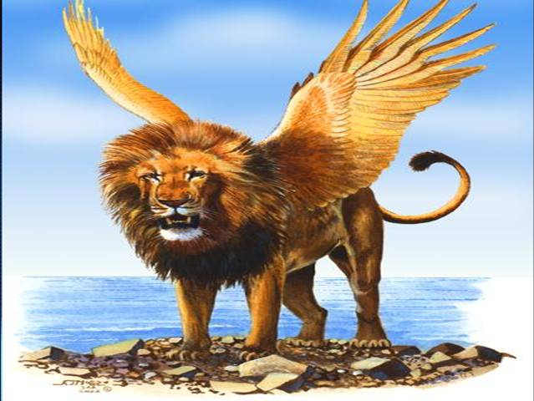 |  | 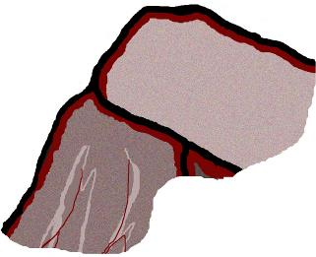  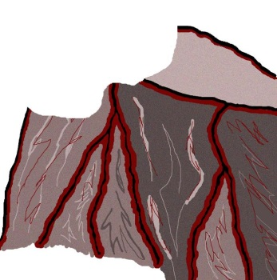  
 | 
 |  | 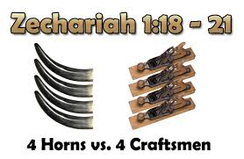
 | 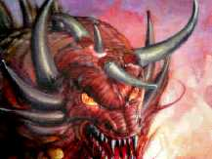 | 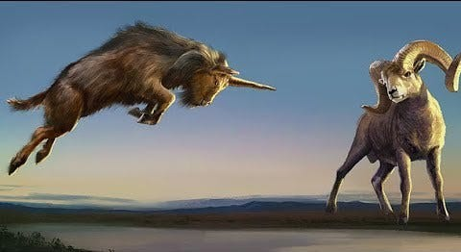
 | 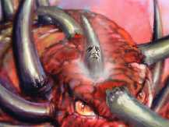 | Daniel 8

VIII. Don’t Be Ignorant of the Mystery – Romans 9-11
IX. The Kingdom After Israel is Returned – Zechariah 14
X. All was Prophesied in the Feasts of Leviticus
Time of the Feasts
Months of the New Calendar year the feasts of God are Celebrated
Feasts | 1st Three Feasts- Passover | Summer feast - Pentecost | Last Three Feasts - Tabernacles
Months | March / April | May / June | September/ October
Season | Spring | Summer - 50 Days after Firstfruits | Fall
Advent | Christ’s First Advent | Holy Ghost Advent | Christ’s Second Advent
References of the Feasts
Name of Feast | Reference | Type
Passover | Exodus 12:1-10; Leviticus 23:1-5 | Redemption
Unleavened Bread | Exodus 12:10-20; Leviticus 23:6-8 | Sanctification
First Fruits | Leviticus 23:9-14 | Resurrection
Pentecost | Leviticus 23:15-22 | Advent of the Holy Spirit - Church Begins
Trumpets | Leviticus 23:23-25 | Rapture of the Church
Day of Atonement | Leviticus 23:26-32 | Israel Restored @ 2nd Advent of Christ
Tabernacles | Leviticus 23:33-44 | Millennium
Foreshadow of the Feasts
Name of the Feast | Reference | Hebrew Name | Foreshadow | Foreshadow Reference
Passover | Leviticus 23:1-5  Exodus 12:1-10 | Pesch | Redemption  1st Advent of Christ | I Corinthians 5:7; Romans 3-4
Unleavened Bread | Leviticus 23:6-8  Exodus 12:10-20 | Matza | Sanctification | I Corinthians 5:8; Romans 5-8:20
First Fruits | Leviticus 23:9-14 | Barley & Flax Harvest | Resurrection – Firstfruits of them that slept | I Corinthians 15
Pentecost | Leviticus 23:15-22 | Shavuot (Weeks) | Advent of the Holy Spirit (church)  Type of Spirit pouring upon Israel | John 20 - Acts 2 - Joel 2
Hebrew summer harvest for 4 months between feasts foreshadows:  The church sent by Christ to sew the summer (wheat) field |  |  |  | John 4:28 - 42; 20:18-23  Luke 19:1-27
Trumpets | (22 as transition)  Leviticus 23:23-25  Numbers29:1-6 | Rosh Hashanah (New Year)  (Yam Teruah) | Type of Rapture of the Church,  Tribulation Resurrections, and Israel’s awakening (Dan. 12:1-3) | I Thessalonians 4:12 - 18  I Corinthians 15:50-58  John 14:1-4
Day of Atonement | Leviticus 23:26-32 | Yom Kippur | Israel’s Restoration  2nd Advent of Christ | Leviticus 16; Zechariah 12; Romans 11; Ezekiel 37-39
Tabernacles | Leviticus 23:33-44 | Sukkot | Millennium | Zechariah 14  Revelation 19-20

XI. The Second Advent – Revelation 19
After Babylon, the Great whore, has been destroyed all heaven is rejoicing:
Revelation 19:1 And after these things I heard a great voice of much people in heaven, saying, Alleluia; Salvation, and glory, and honour, and power, unto the Lord our God:
Revelation 19:2 For true and righteous are his judgments: for he hath judged the great whore, which did corrupt the earth with her fornication, and hath avenged the blood of his servants at her hand.
Revelation 19:3 And again they said, Alleluia. And her smoke rose up for ever and ever.
Revelation 19:4 And the four and twenty elders and the four beasts fell down and worshipped God that sat on the throne, saying, Amen; Alleluia.
Revelation 19:5 And a voice came out of the throne, saying, Praise our God, all ye his servants, and ye that fear him, both small and great.
The Marriage of the Lamb
Revelation 19:6 And I heard as it were the voice of a great multitude, and as the voice of many waters, and as the voice of mighty thunderings, saying, Alleluia: for the Lord God omnipotent reigneth.
Revelation 19:7 Let us be glad and rejoice, and give honour to him: for the marriage of the Lamb is come, and his wife hath made herself ready.
Revelation 19:8 And to her was granted that she should be arrayed in fine linen, clean and white: for the fine linen is the righteousness of saints.
Revelation 19:9 And he saith unto me, Write, Blessed are they which are called unto the marriage supper of the Lamb. And he saith unto me, These are the true sayings of God.
Revelation 19:10 And I fell at his feet to worship him. And he said unto me, See thou do it not: I am thy fellowservant, and of thy brethren that have the testimony of Jesus: worship God: for the testimony of Jesus is the spirit of prophecy.
The Second Advent
Revelation 19:11 And I saw heaven opened, and behold a white horse; and he that sat upon him was called Faithful and True, and in righteousness he doth judge and make war.
Revelation 19:12 His eyes were as a flame of fire, and on his head were many crowns; and he had a name written, that no man knew, but he himself.
Revelation 19:13 And he was clothed with a vesture dipped in blood: and his name is called The Word of God.
Revelation 19:14 And the armies which were in heaven followed him upon white horses, clothed in fine linen, white and clean.
Revelation 19:15 And out of his mouth goeth a sharp sword, that with it he should smite the nations: and he shall rule them with a rod of iron: and he treadeth the winepress of the fierceness and wrath of Almighty God.
Revelation 19:16 And he hath on his vesture and on his thigh a name written, KING OF KINGS, AND LORD OF LORDS.
Revelation 19:17 And I saw an angel standing in the sun; and he cried with a loud voice, saying to all the fowls that fly in the midst of heaven, Come and gather yourselves together unto the supper of the great God;
Revelation 19:18 That ye may eat the flesh of kings, and the flesh of captains, and the flesh of mighty men, and the flesh of horses, and of them that sit on them, and the flesh of all men, both free and bond, both small and great.
Revelation 19:19 And I saw the beast, and the kings of the earth, and their armies, gathered together to make war against him that sat on the horse, and against his army.
Revelation 19:20 And the beast was taken, and with him the false prophet that wrought miracles before him, with which he deceived them that had received the mark of the beast, and them that worshipped his image. These both were cast alive into a lake of fire burning with brimstone.
Revelation 19:21 And the remnant were slain with the sword of him that sat upon the horse, which sword proceeded out of his mouth: and all the fowls were filled with their flesh.
XII. The Eternal Kingdom
Revelation 20:1 And I saw an angel come down from heaven, having the key of the bottomless pit and a great chain in his hand.
Revelation 20:2 And he laid hold on the dragon, that old serpent, which is the Devil, and Satan, and bound him a thousand years,
Revelation 20:3 And cast him into the bottomless pit, and shut him up, and set a seal upon him, that he should deceive the nations no more, till the thousand years should be fulfilled: and after that he must be loosed a little season.
Revelation 20:4 And I saw thrones, and they sat upon them, and judgment was given unto them: and I saw the souls of them that were beheaded for the witness of Jesus, and for the word of God, and which had not worshipped the beast, neither his image, neither had received his mark upon their foreheads, or in their hands; and they lived and reigned with Christ a thousand years.
Revelation 20:5 But the rest of the dead lived not again until the thousand years were finished. This is the first resurrection.
Revelation 20:6 Blessed and holy is he that hath part in the first resurrection: on such the second death hath no power, but they shall be priests of God and of Christ, and shall reign with him a thousand years.
Revelation 20:7 And when the thousand years are expired, Satan shall be loosed out of his prison,
Revelation 20:8 And shall go out to deceive the nations which are in the four quarters of the earth, Gog and Magog, to gather them together to battle: the number of whom is as the sand of the sea.
Revelation 20:9 And they went up on the breadth of the earth, and compassed the camp of the saints about, and the beloved city: and fire came down from God out of heaven, and devoured them.
Revelation 20:10 And the devil that deceived them was cast into the lake of fire and brimstone, where the beast and the false prophet are, and shall be tormented day and night for ever and ever.
XII. The Eternal Kingdom
Eternity
Revelation 21:1 And I saw a new heaven and a new earth: for the first heaven and the first earth were passed away; and there was no more sea.
Revelation 21:2 And I John saw the holy city, new Jerusalem, coming down from God out of heaven, prepared as a bride adorned for her husband.
The Tabernacle of God is with men
Revelation 21:3 And I heard a great voice out of heaven saying, Behold, the tabernacle of God is with men, and he will dwell with them, and they shall be his people, and God himself shall be with them, and be their God.
Revelation 21:4 And God shall wipe away all tears from their eyes; and there shall be no more death, neither sorrow, nor crying, neither shall there be any more pain: for the former things are passed away.
Revelation 21:5 And he that sat upon the throne said, Behold, I make all things new. And he said unto me, Write: for these words are true and faithful.
The water of Life given freely – Kingdom like no other
Revelation 21:6 And he said unto me, It is done. I am Alpha and Omega, the beginning and the end. I will give unto him that is athirst of the fountain of the water of life freely.
Revelation 21:7 He that overcometh shall inherit all things; and I will be his God, and he shall be my son.
Revelation 21:8 But the fearful, and unbelieving, and the abominable, and murderers, and whoremongers, and sorcerers, and idolaters, and all liars, shall have their part in the lake which burneth with fire and brimstone: which is the second death.
Revelation 21:9 And there came unto me one of the seven angels which had the seven vials full of the seven last plagues, and talked with me, saying, Come hither, I will shew thee the bride, the Lamb's wife.
Revelation 21:10 And he carried me away in the spirit to a great and high mountain, and shewed me that great city, the holy Jerusalem, descending out of heaven from God,
Revelation 21:11 Having the glory of God: and her light was like unto a stone most precious, even like a jasper stone, clear as crystal;
Revelation 21:12 And had a wall great and high, and had twelve gates, and at the gates twelve angels, and names written thereon, which are the names of the twelve tribes of the children of Israel:
Revelation 21:13 On the east three gates; on the north three gates; on the south three gates; and on the west three gates.
Revelation 21:14 And the wall of the city had twelve foundations, and in them the names of the twelve apostles of the Lamb.
Revelation 21:15 And he that talked with me had a golden reed to measure the city, and the gates thereof, and the wall thereof.
Revelation 21:16 And the city lieth foursquare, and the length is as large as the breadth: and he measured the city with the reed, twelve thousand furlongs. The length and the breadth and the height of it are equal.
Revelation 21:17 And he measured the wall thereof, an hundred and forty and four cubits, according to the measure of a man, that is, of the angel.
Revelation 21:18 And the building of the wall of it was of jasper: and the city was pure gold, like unto clear glass.
Revelation 21:19 And the foundations of the wall of the city were garnished with all manner of precious stones. The first foundation was jasper; the second, sapphire; the third, a chalcedony; the fourth, an emerald;
Revelation 21:20 The fifth, sardonyx; the sixth, sardius; the seventh, chrysolite; the eighth, beryl; the ninth, a topaz; the tenth, a chrysoprasus; the eleventh, a jacinth; the twelfth, an amethyst.
Revelation 21:21 And the twelve gates were twelve pearls; every several gate was of one pearl: and the street of the city was pure gold, as it were transparent glass.
Revelation 21:22 And I saw no temple therein: for the Lord God Almighty and the Lamb are the temple of it.
Revelation 21:23 And the city had no need of the sun, neither of the moon, to shine in it: for the glory of God did lighten it, and the Lamb is the light thereof.
Revelation 21:24 And the nations of them which are saved shall walk in the light of it: and the kings of the earth do bring their glory and honour into it.
Revelation 21:25 And the gates of it shall not be shut at all by day: for there shall be no night there.
Revelation 21:26 And they shall bring the glory and honour of the nations into it.
Revelation 21:27 And there shall in no wise enter into it any thing that defileth, neither whatsoever worketh abomination, or maketh a lie: but they which are written in the Lamb's book of life.

